Angular and Spring Boot E-commerce App Steps

Format: shift + option + F

Overview

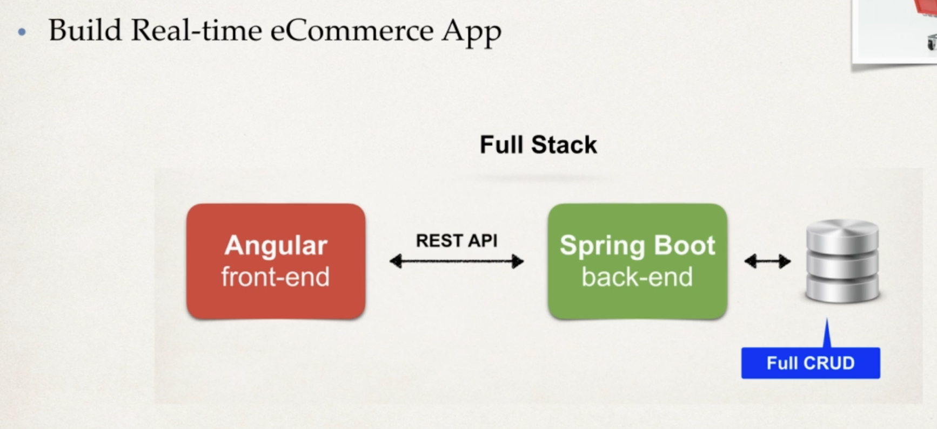

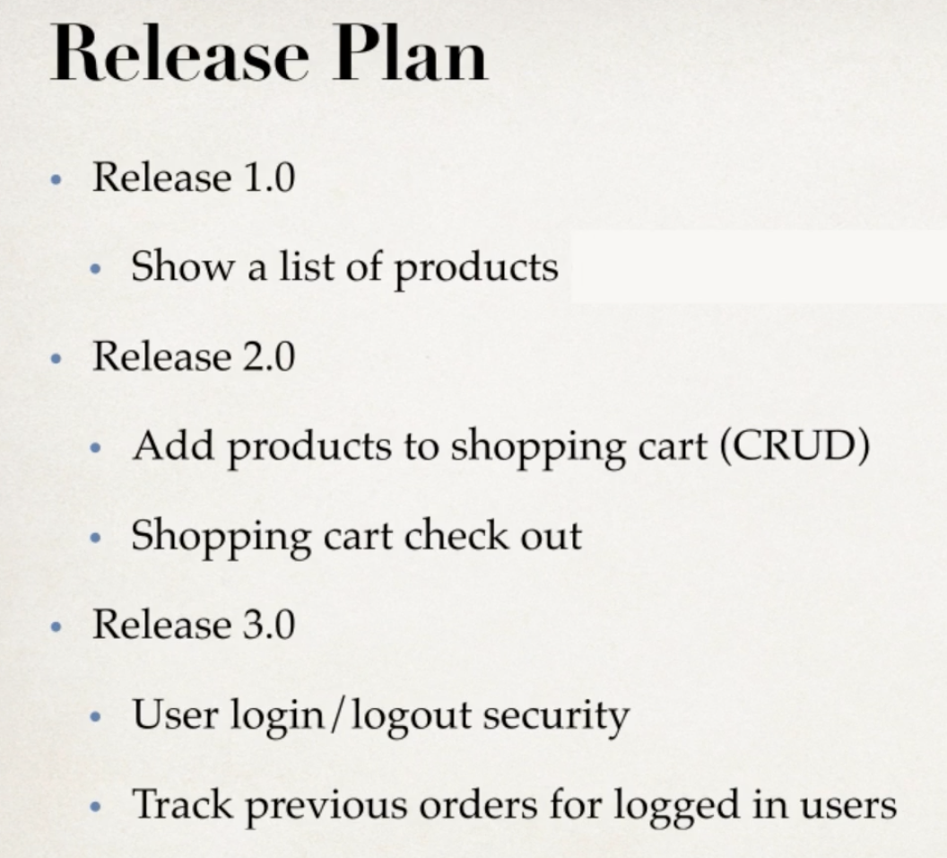

09 SpringBoot Backend

Development Process:

1. Set up the database tables: MySQL
2. Create a SpringBoot starter project (start.spring.io)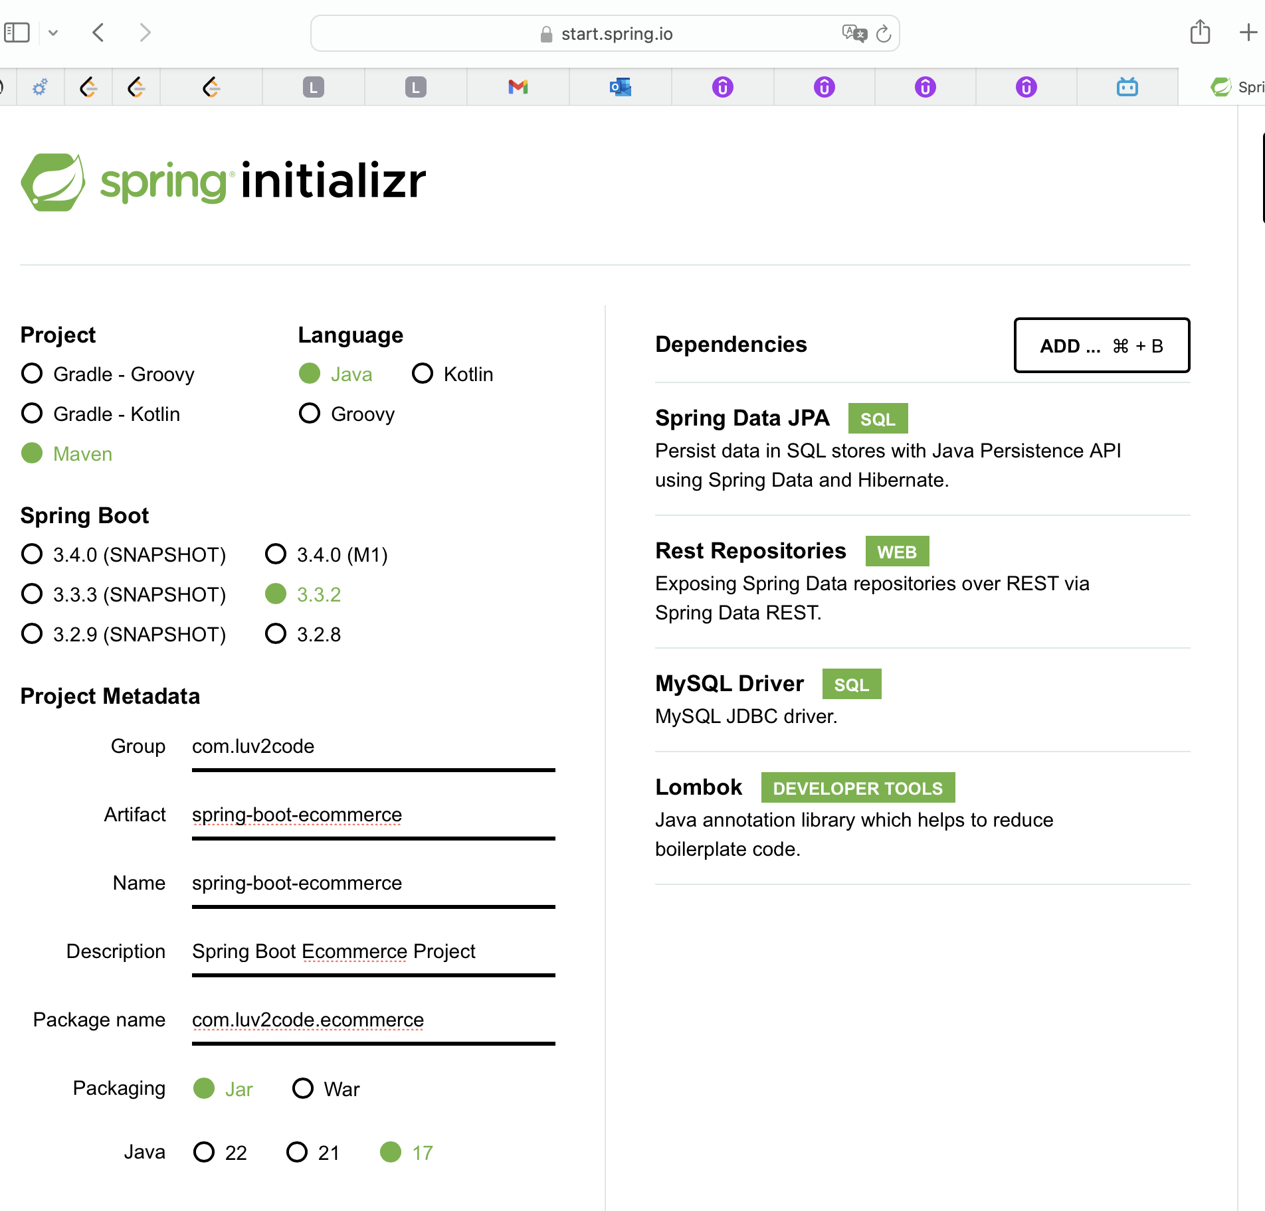
3. Develop the Entities: Product and Product Category
   1. New package: entity -> new java class: Product and ProductCategory
   2. Note: ManyToOne, OneToMany
4. Create REST APIs with Spring Data JPA Repositories and Spring Data REST
   1. New package: dao -> new Interface: ProductRepository and ProductCategoryRepository
5. Make the REST API as READ-ONLY
   1. New package: config -> new java class: MyDataRestConfig
   2. Disable HTTP methods: POST, PUT, DELETE
   3. Test with Postman

10 Augular Frontend

Development process

1. Create Angular project
   1. Terminal; ng new angular-ecommerce -> n for routing, CSS
2. Create Angular component for product-list
   1. Ng generate component components/product-list
3. Develop TypeScript class for Product
   1. Ng generate class common/product
   2. Add constructor
4. Create Angular service to call REST APIs  
   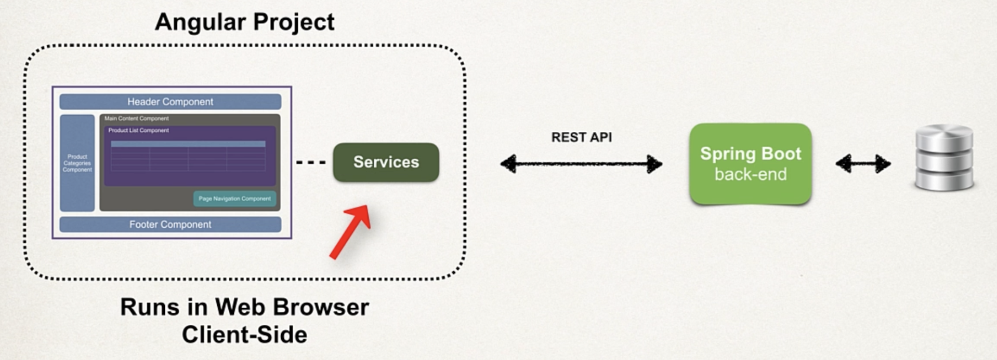
   1. Ng generate service services/product
   2. App.module.ts: add HttpClientModule and ProductService
   3. Product.service.ts: Inject HttpClient; Map the JSON data from SpringData REST to Product array; Unwraps the JSON from Spring Data REST _embedded entry
5. Update Angular component to subscribe to data from Angular service
   1. Product-list.component.ts: Inject ProductService, subscribe, integrating service with angular component
6. Display the data in an HTML page
   1. Product-list.component.html
   2. Display list of products in an HTML table
7. Add CrossOrigin support to Spring Boot app
   1. Specific to JavaScript running on website.  
      Origin = protocol + hostname + port
   2. ProductRepository: add @CrossOrigin
   3. The same for ProductCategoryRepository
8. Add images to assets directory

11 Integrating online shop template

Release 2.0 – Plan

* Online shop template integration
* Search for products by category
* Search for products by text box
* Master / detail view of products
* Pagination
* Add products to shopping cart (CRUD)
* Shopping carts check out

Development Process

1. Download the HTML template starter files
2. Install Bootstrap CSS styles locally using npm
   1. Npm install bootstrap
   2. Npm install fortawesome/fontawesome-free
3. Add local custom CSS styles to Angular src/styles.css file
4. Integrate template files into Angular app
   1. Source -> app -> App.component.html
   2. Copy from home.html
      1. Menu sidebar
      2. Container – Desktop
      3. Footer
5. Add support for icons and logos
   1. copy product-list-table.component.html and rename to product-list-grid.component.html
6. Enhance our application with product images
   1. Copy asset pictures to assets -> images -> products folder

12 Search for products by category

Angular Route

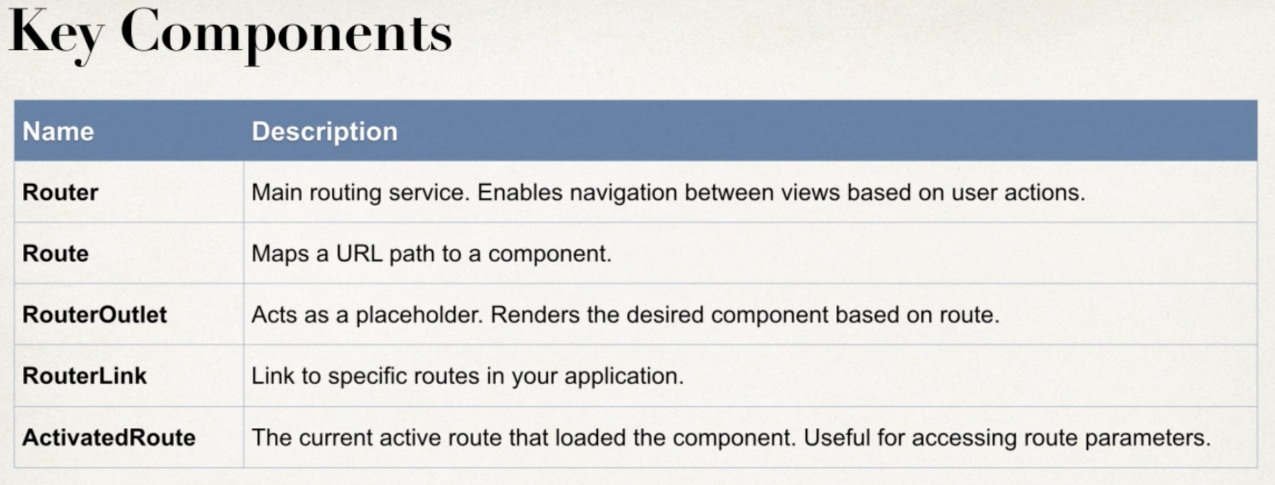

Development Process

1. Define routes
   1. App.module.ts: define routes
   2. Specfic -> generic -> 404
2. Configure Router based on our routes
   1. @NgModule -> imports -> RouterModule.forRoot(routes)
3. Define the Router Outlet
   1. App.component.html
4. Set up Router Links to pass category id param
   1. App.component.html -> Menu sidebar -> href replace with routerLink
5. Enhance ProductListComponent to read category id param
   1. product-list.component.ts: add currentCategoryId: number = 1
   2. Constructor -> Inject the ActivatedRoute
   3. ngOnInit() this.route.paramMap.subscribe()…
6. Modify SpringBoot app – REST Repository needs new method
   1. ProductRepository add method
7. Update Angular Service to call new URL on Spring Boot app
   1. Product.service.ts -> getProductList()

13 Search for products by category (dynamic)

Development Process

1. Modify Spring Boot app – Expose entity ids
   1. MyDataRestConfig: add EntityManager
   2. Get a list of all entity classes from the entity manager
   3. Create an array of the entity types
   4. Get the entity types for the entities
   5. Expose the entity ids for the array of entity / domain types
2. Create a class: ProductCategory
   1. ng generate class common/product-category
3. Create new component for menu
   1. ng generate component components/product-category-menu
      1. product-category-menu.ts
4. Enhance menu component to read data from product service  
   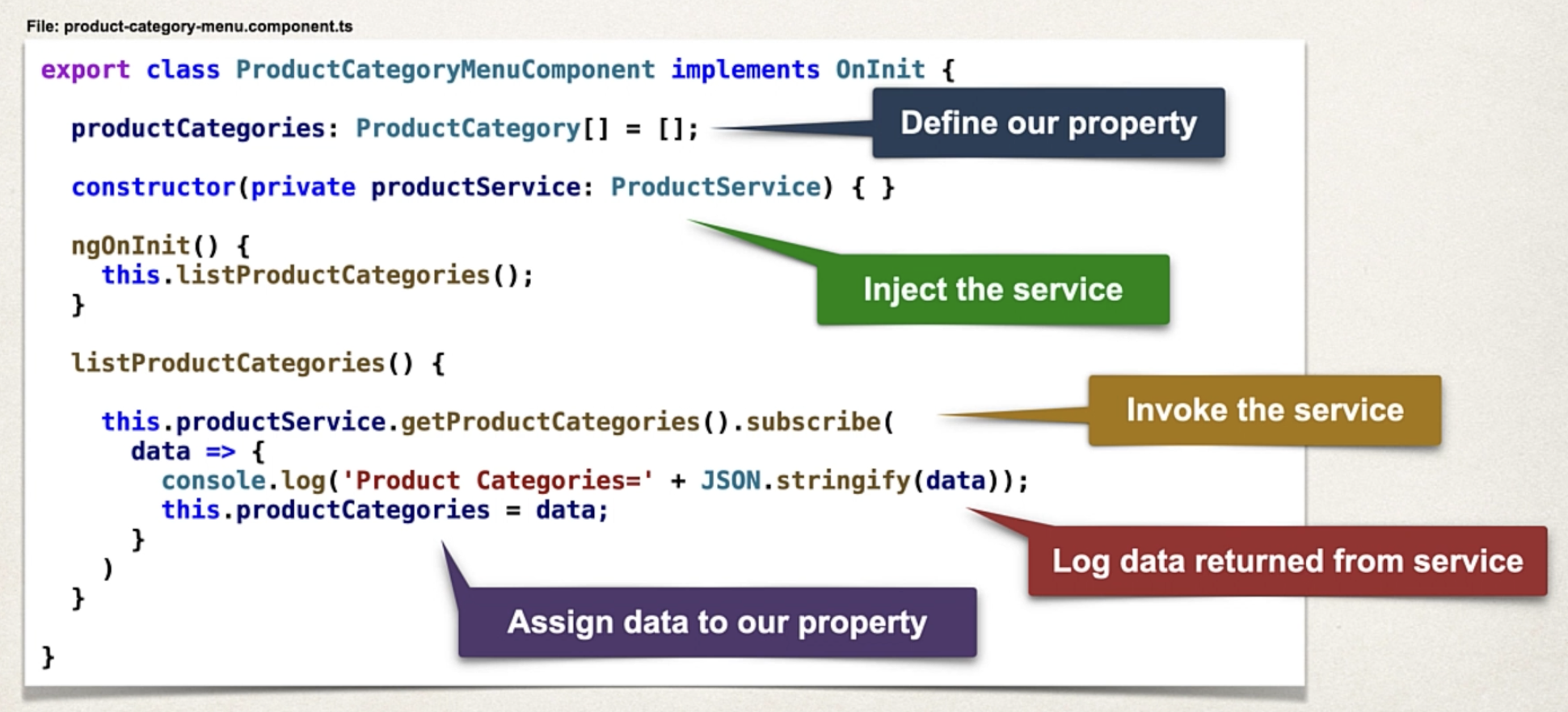
5. Update product service to call URL on Spring Boot app
   1. Product.service.ts
6. In HTML, replace hard-coded links with menu component
   1. App.component.html: update hard-coded links; copy selector from product-category-menu.component.ts
   2. Product-category-menu.component.html

14 Search by keyword

1. Modify Spring Boot app – Add a new search method
   1. Dao -> ProductRepository
2. Create new component for search
   1. ng generate component components/search
3. Add new Angular route for searching
   1. App.module.ts
4. Update SearchComponent to send data to search route
   1. App.component.html copy and paste to search.component.html
   2. Supporting code for search button: search.component.ts
5. Enhance ProductListComponent to search for products with ProductService
   1. Product-list.component.ts: add handleListProducts()
   2. What about product not found? Display a message.
      1. Product-list-grid.component.html
6. Update ProductService to call URL on SpringBoot app
   1. Product-service.ts: create method: searchProducts()
   2. Refactor: make the code concise and reusable

15 Master Detail view

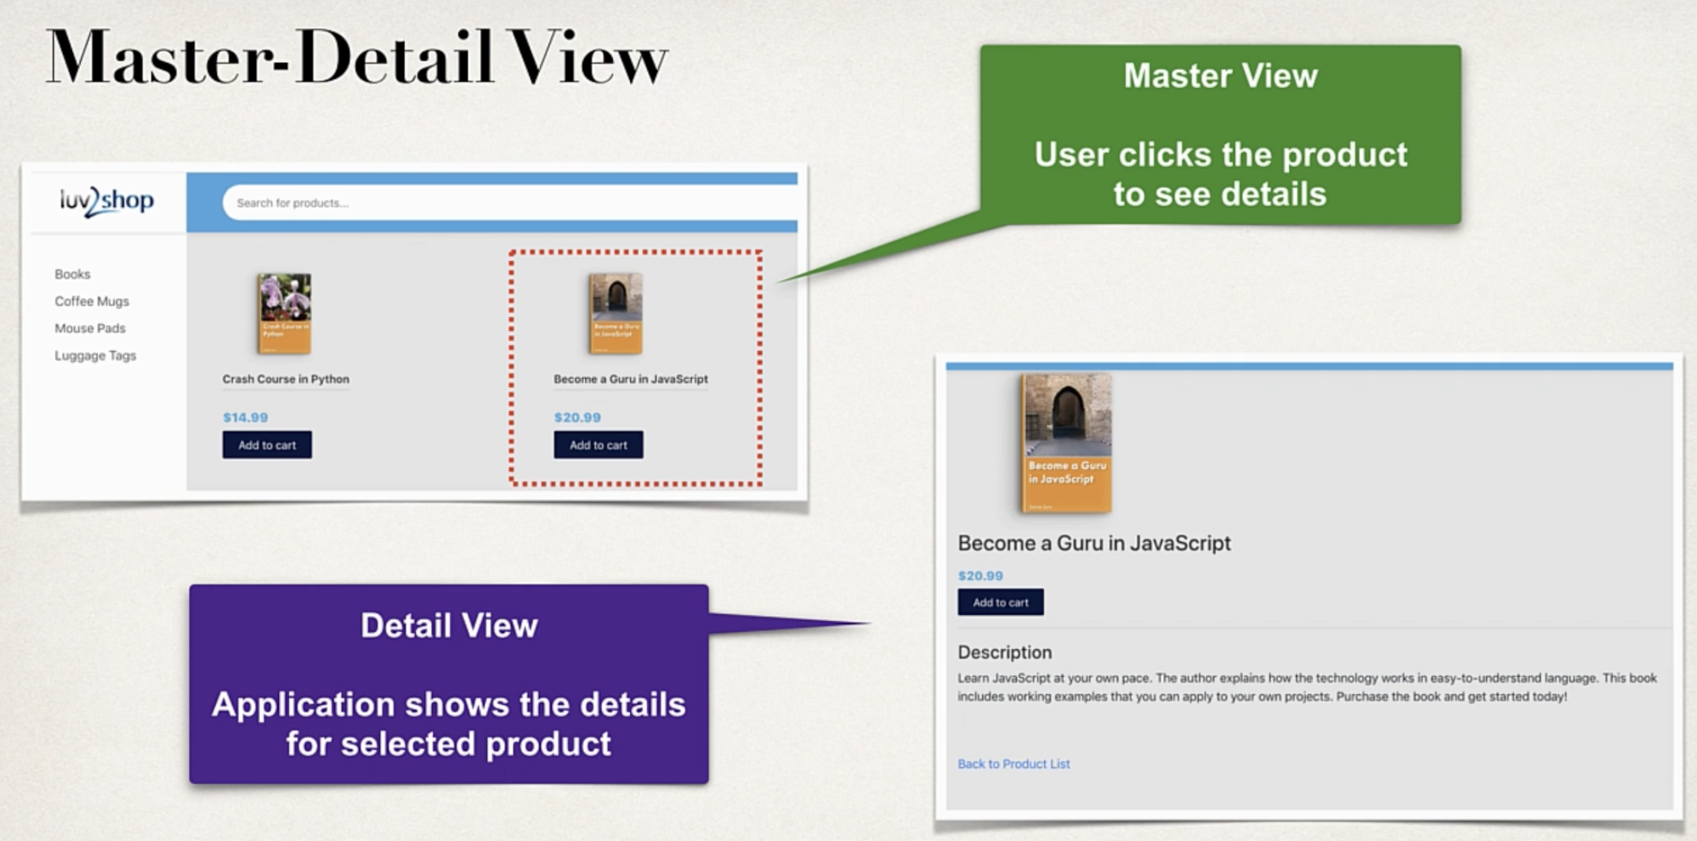

Development process

1. Create new component for product details
   1. Ng generate component components/ProductDetails
2. Add new Angular route for product details  
   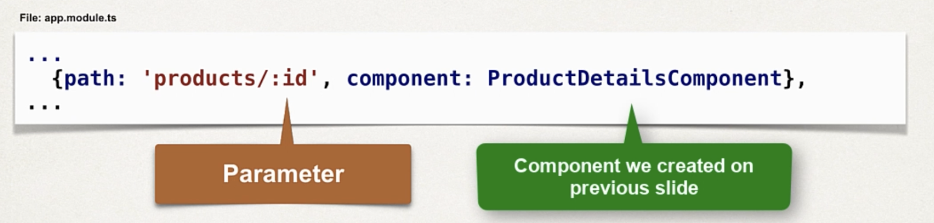
3. Add router links to the product-list-grid HTML page
4. Enhance ProductDetailsComponent to retrieve products from ProductService
5. Update PorductService to call URL on Spring Boot app  
   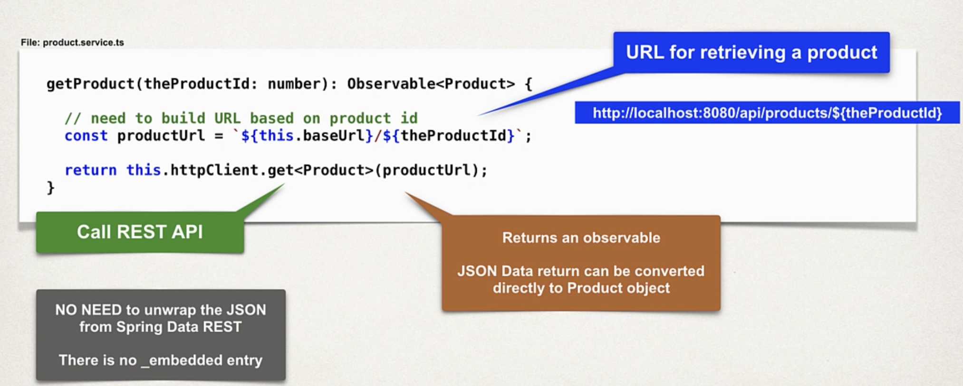
6. Update HTML page for ProductDetailsComponent to display product details  
   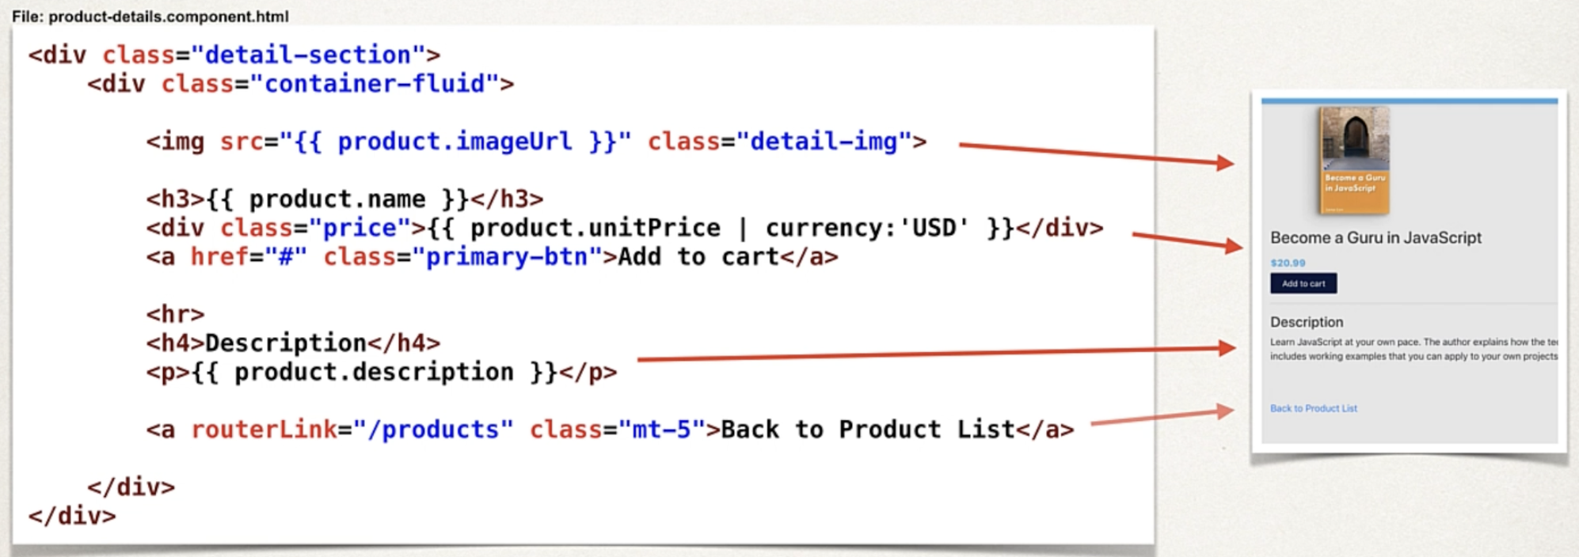

16 Pagination

Development Process

1. Install ng-bootstrap
   1. ng add @angular/localize
   2. npm install @ng-bootstrap/ng-bootstrap@13.0.0
   3. app.module.ts: imports: NgbModule
2. Refactor the interface for: GetResponseProducts
   1. Services -> product.service.ts: GetResponseProducts() add page:{}
3. Add pagination support to ProductService
   1. Product.service.ts: getProductListPaginate()
4. Update ProductListComponent to handle pagination
   1. Product-list.component.ts: new property for pagination: thePageNumber, thePageSize, theTotalElement
   2. handleListProducts()
   3. note: pagination component: pages are 1 based; while Spring Data REST pages are 0 based
5. Enhance HTML template to use ng-bootstrap pagination component
   1. Product-list-grid component.html  
      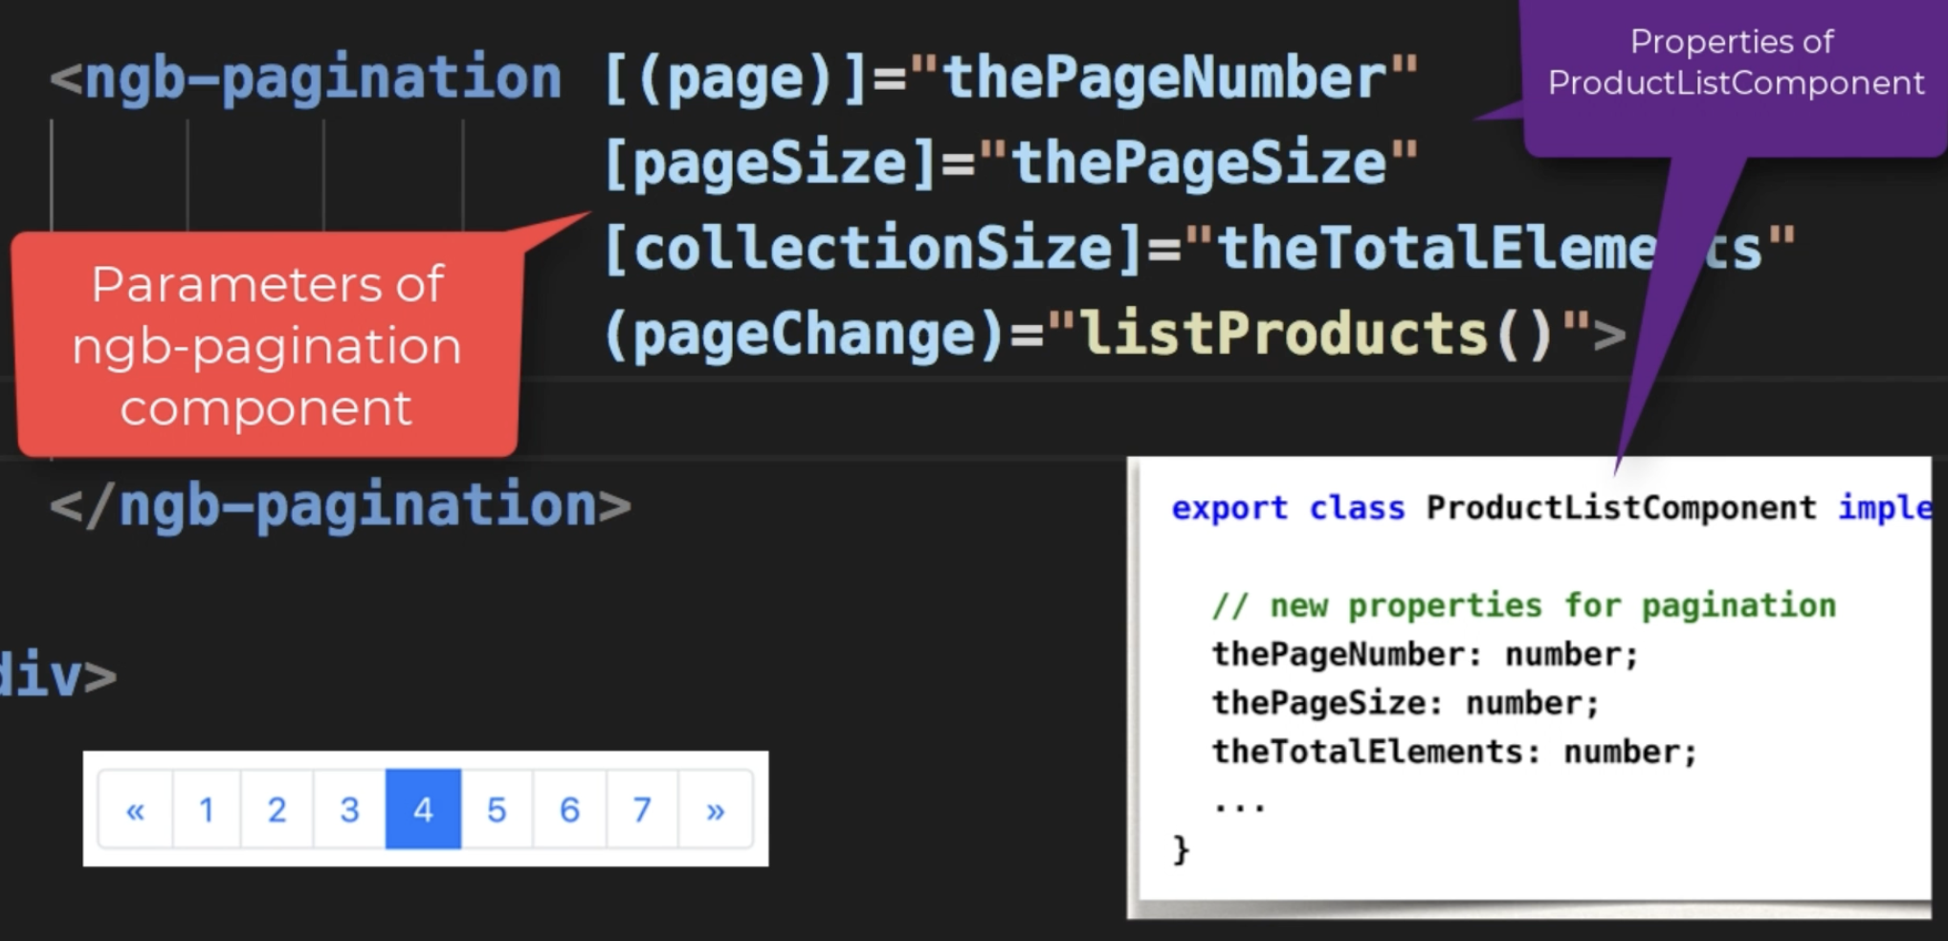

Allow user to change the page size

1. Add drop-down list for page size to HTML template
   1. Product-list.component.ts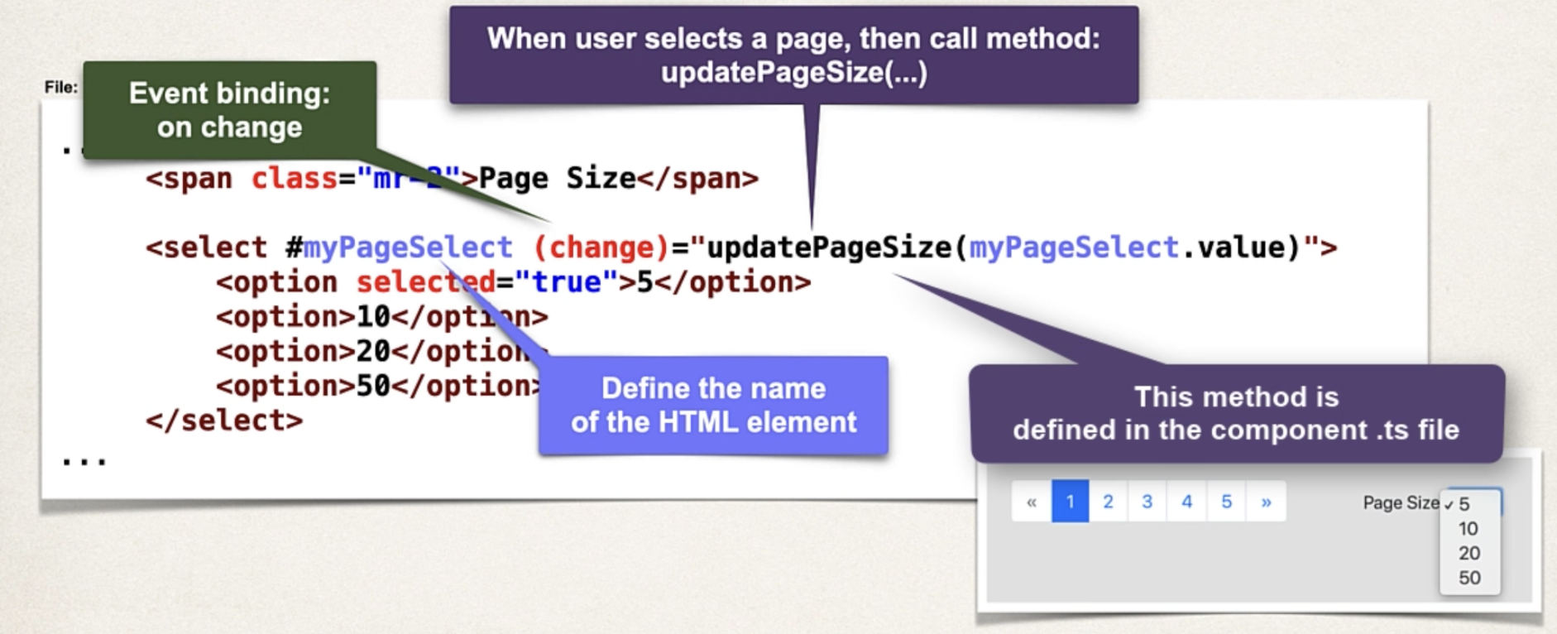
2. Update ProductListComponent for setting page size  
   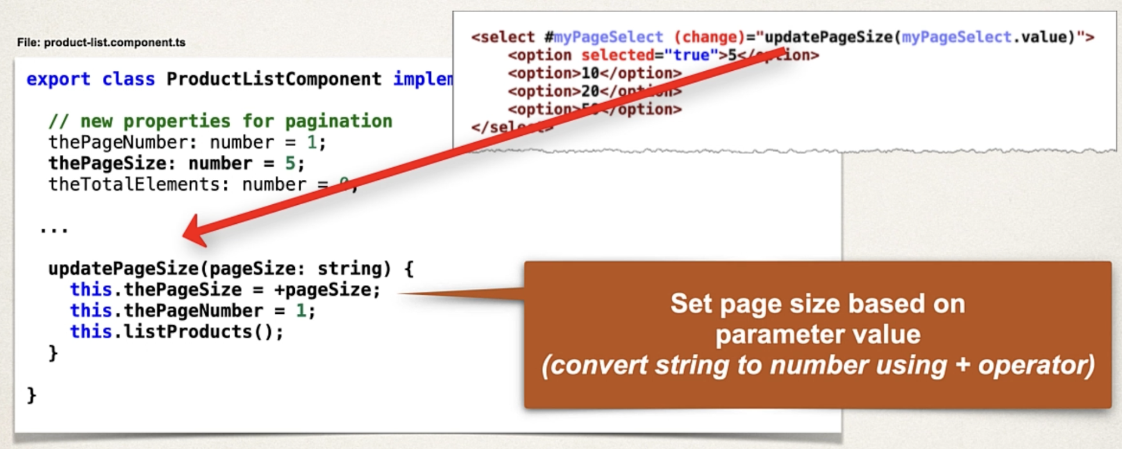

Pagination for keyword search

1. Add pagination support to ProductService
   1. Product.service.ts: add searchProductsPaginate()
2. Update ProductListComponent to handle pagination
   1. Product-list.component.ts

17 shopping cart – part 1

1. Cart Status Component: on main page, display total price and quantity  
   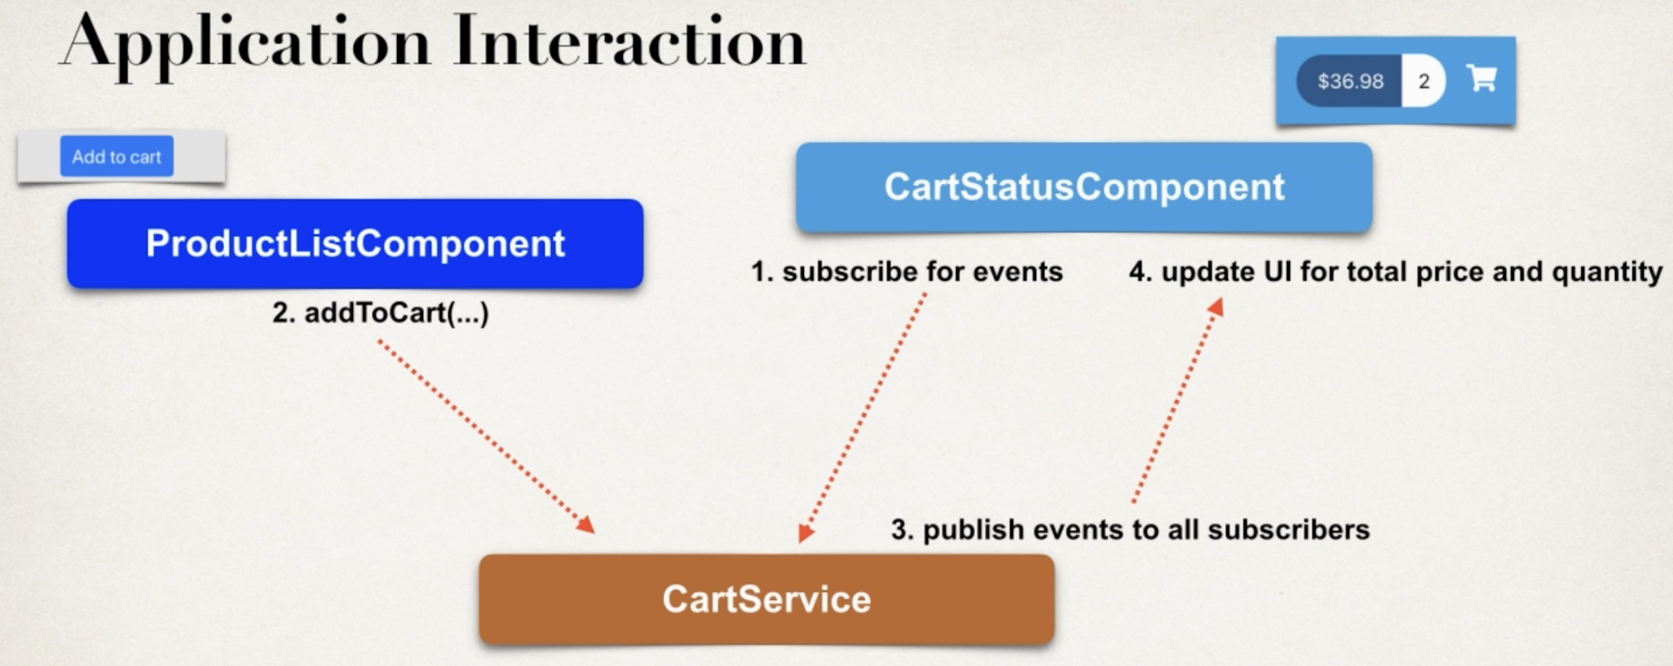
   1. Create new component: CartStatusComponent
      1. Ng generate component components/cart-status
   2. Add HTML template for CartStatusComponent
      1. Cart-status.component.html
   3. Add click handler for “Add to cart” button
      1. Product-list-grid.component.html
   4. Update ProductListComponent with click handler method
      1. Product-list.component.ts: add addToCart()
   5. Create model class: CartItem
      1. Ng generate class common/cart-item
      2. Common -> cart-item.ts
   6. Develop CartService
      1. Ng generate service services/cart
      2. addToCart
   7. Modify ProductListComponent to call CartService
      1. Product-list.component.ts
   8. Enhance CartStatusComponent to subscribe to CartService
      1. Cart-status.component.ts
   9. Update CartStatusComponent HTML to display cart total price and quantity
      1. Cart-status.component.html
   10. Add click handler for “Add to cart” button on product-details.component.html
   11. Update ProductDetailsComponent with click handler method
2. Cart Details Page: list the items in the cart
3. Cart Details Page: add / remove items
4. Checkout Button
5. Checkout Form

18 Shopping cart items CRUD

Development process

1. Create new component: CartDetailsComponent
   1. Ng generate component components/cart-details
2. Add new route for CartDetailsComponent
   1. App.module.ts add path
3. Update link for Shopping Cart icon
   1. Cart-status.component.html: routerLink
4. Modify CartDetailsComponent to retrieve cart items
   1. Cart-details.component.ts
5. Add HTML template for CartDetailsComponent
   1. Cart-details.component.html  
      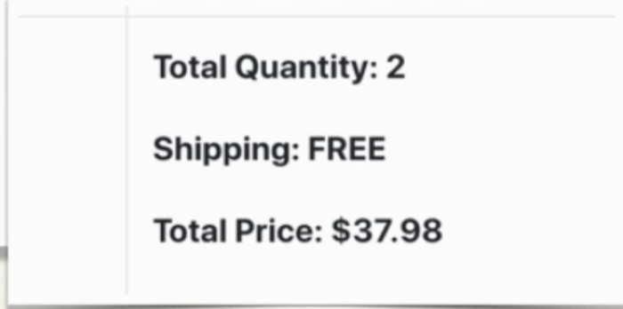
   2. Empty cart?
      1. App.component.html: menu sidebar
      2. Cart-details.component.html
6. Increment Item Quantity in the shopping cart (similar: decrement, remove)
   1. Modify CartDeyailsComponent HTML template
      1. Add the “increment” button: cart-details.component.html
      2. Add click handler for the increment button on HTML template
         1. Cart-details.component.ts
   2. Update CartDetailsComponent with click handler method
      1. Cart-details.component.ts

19 Checkout form layout

1. Generate checkout component
   1. Ng generate component components/checkout
2. Add a new route for checkout component
   1. App.module.ts: add path
3. Create a new checkout button and link to checkout component
   1. cart-details.component.html: add checkout button
4. Add support for reactive forms
   1. App.module.ts: add ReactiveFormsModule
5. Define form in component .ts file
   1. Checkout.component.ts
6. Layout form controls in HTML template
   1. Checkout.component.html
7. Add event handler for form submission: check.component.ts  
   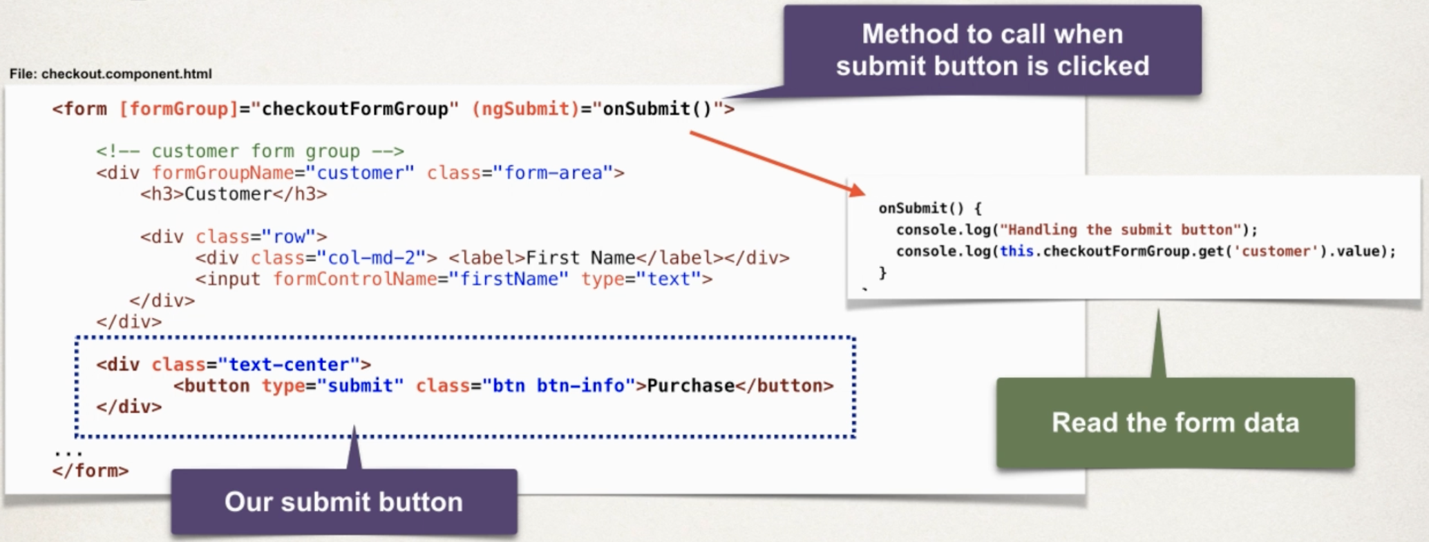

20 Drop down lists

Credit card dates:

1. Generate form service: Luv2ShopFormService
   1. Ng generate service services/Luv2ShopForm
2. Add methods to the form service for months and years
   1. Luv2-shop-form.service.ts
3. Update checkout component to retrieve the months and years from service
   1. Checkout.component.ts: populate credit card months and years
4. Update HTML template to populate drop-down lists for months and years.
   1. Checkout.component.html: Expiration Month and Year

Dependent Fields

* Values for month should depend on the year
* If the current year is selected
  + Then only show the remaining months for the year
  + Start at current month to 12
* If a future year is selected: Show months: 1 – 12

Development process

1. Update HTML template
   1. Checkout.component.html
   2. For the expiration Years drop-down list
   3. Add event binding for change event
2. Update checkout component, add event handler
   1. Checkout.component.ts
   2. Read the selected year
   3. Update the list of months based on selected year

Country and states drop down list - Backend

1. Create database tables
2. Develop JPA Entities (Country, State)
   1. Entity -> Country & State
3. Create Spring Data Repositories
   1. Dao -> CountryRepository
4. Update Spring Data REST Configs
   1. Make Repositories read only

Country and states drop down list – frontend

1. Create TS classes for: Country and State
2. Add methods to the form service for countries and states
   1. Luv2-shop-form.service.ts
3. Update checkout component to retrieve the countries from service
   1. Checkout.component.ts
4. Update HTML template to populate drop-down lists for countries
   1. Checkout.component.html: add getState()
5. Add event handler for checkout component
   1. Read the selected country, retrieve list of states based on selected country
6. Update HTML template to populate drop-down lists for states
   1. Checkout.component.html loop over array shipping address states

21 checkout form validation

1. Specify validation rules for the form controls
   1. Checkout.component.ts
   2. E.g., using regex pattern for email validation:  
      ^[a-zA-Z0-9._%+-]+@[a-zA-Z0-9.-]+\.[a-zA-Z]{2,}$
2. Define Getter methods to access form controls  
   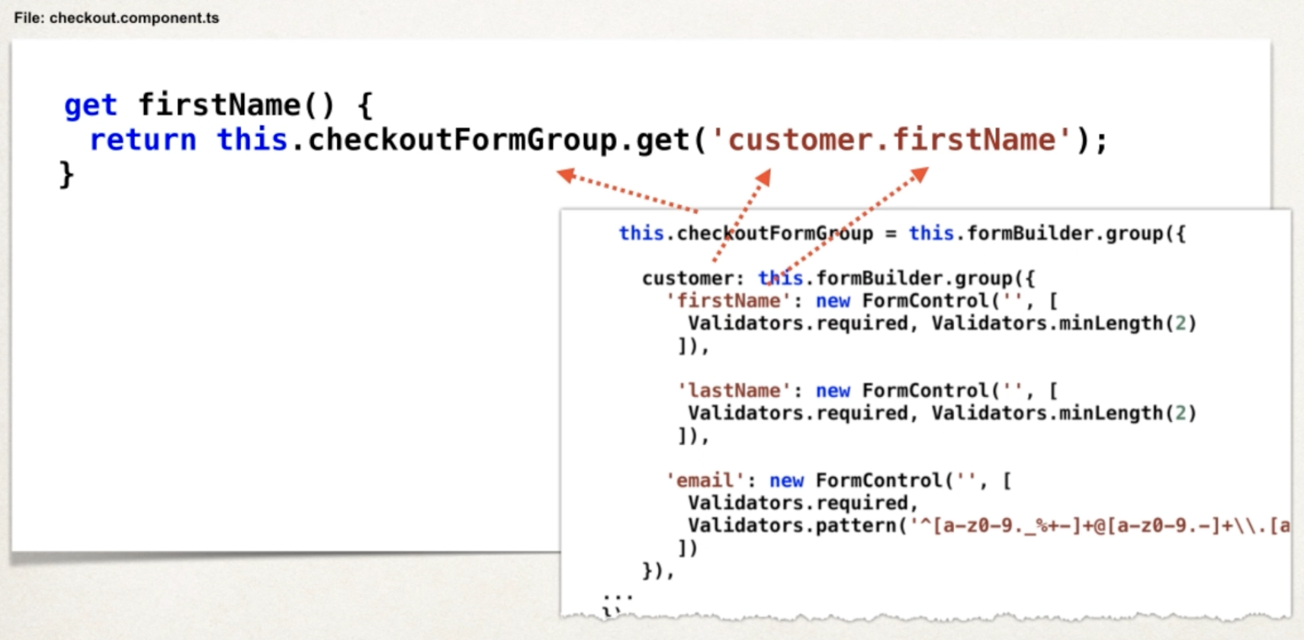
3. Update HTML template to display error messages
4. Add event handler to check validation status when submit button clicked

Custom validator rule – “only white space” not allowed

1. Define custom validator rule
2. Specify custom validator rule for the form controls  
   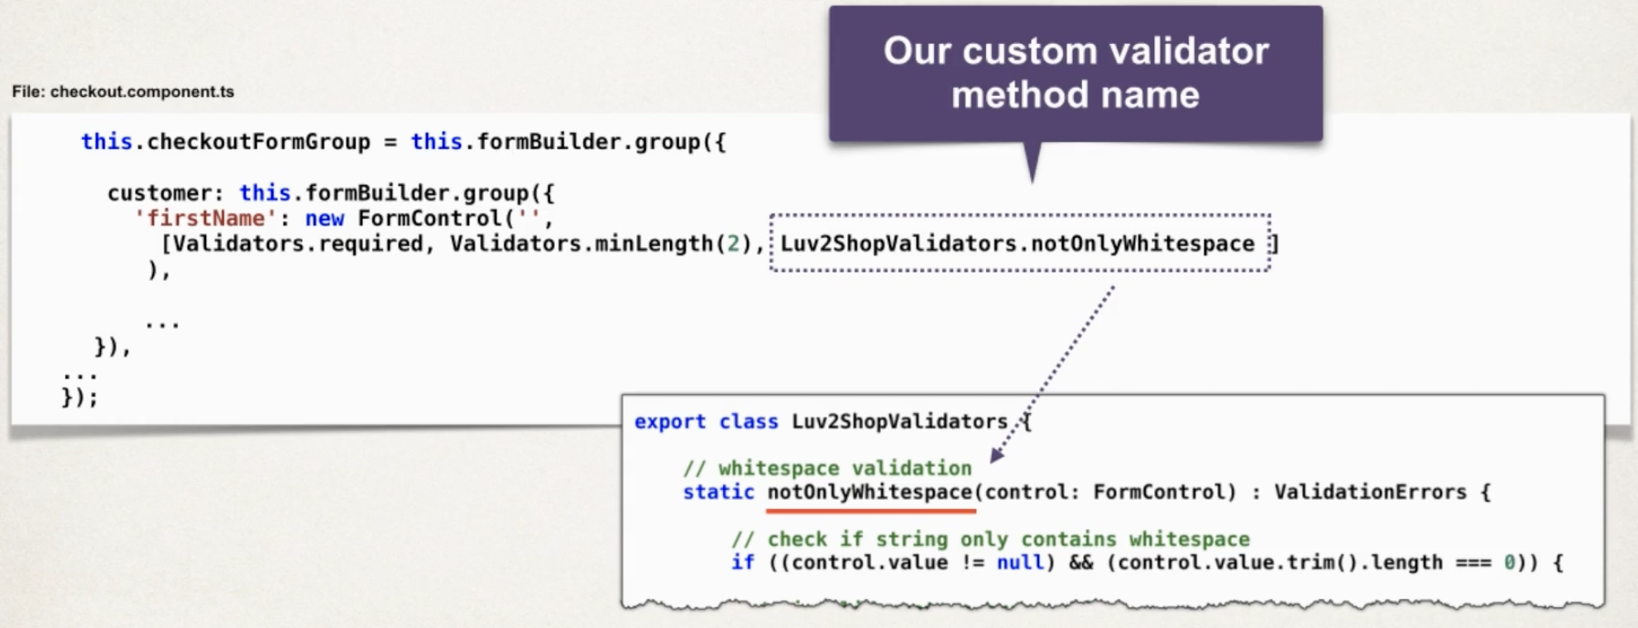
3. Update HTML template to display error messages

22 checkout form & review cart total

Behavior Subject Concept

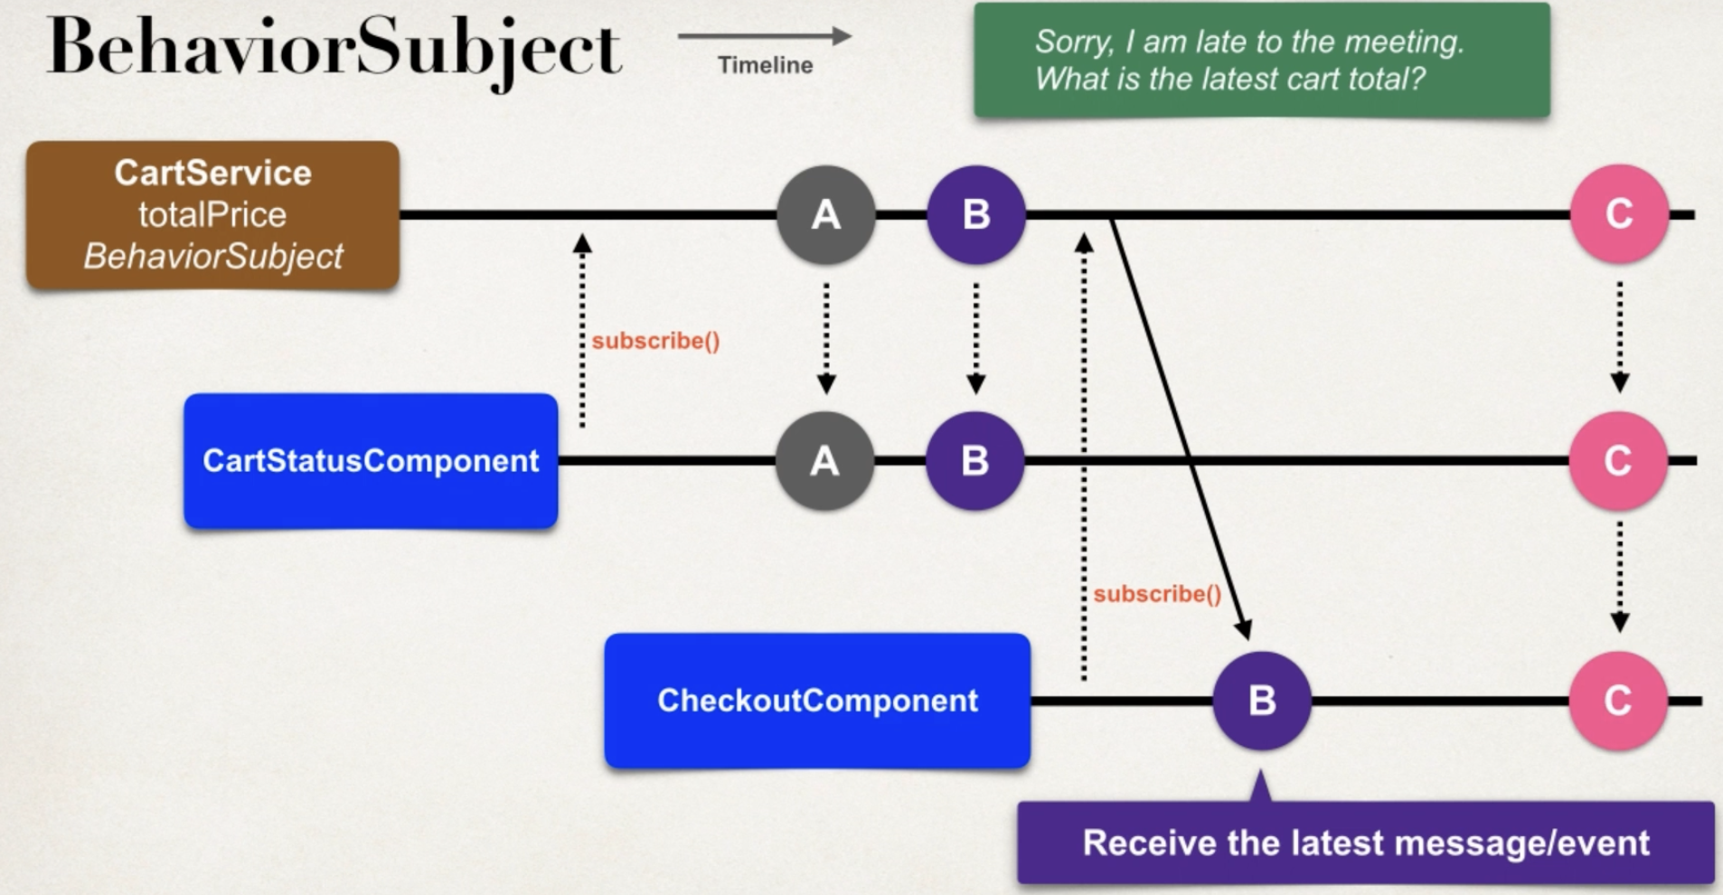

1. Updates for CheckoutComponent
   1. Inject CartService into CheckoutComponent
   2. In ngOnit method, call new method: reviewCartDetails()
   3. Add code for new method: reviewCartDeyails()
2. Update for CartService
   1. Change subject to BehaviorSubject

23 checkout backend

Application Architecture

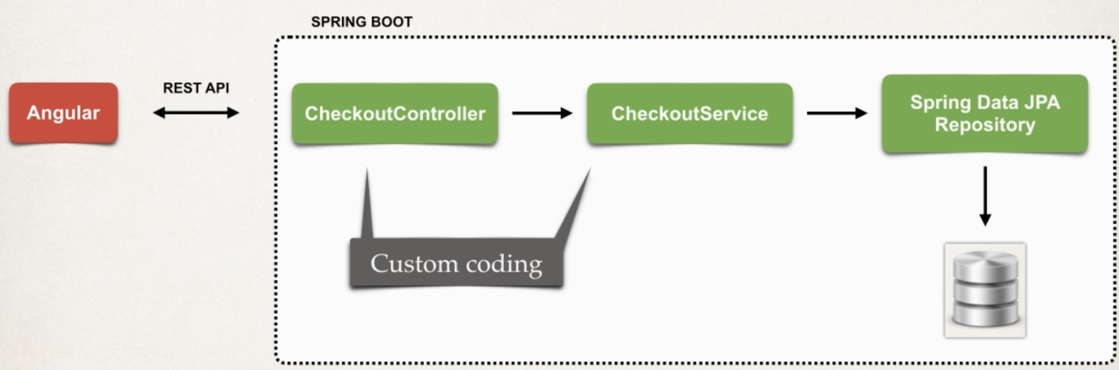

For the Controller and Service, why not using Spring Data REST?  
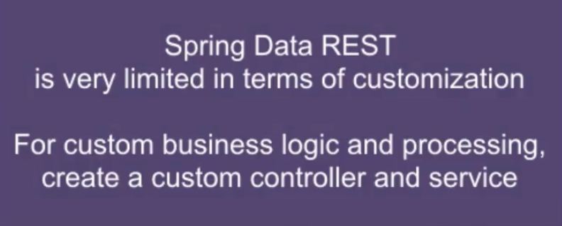

* Spring Data REST is great for basic CRUD
  + We are currently using it for product catalog
* Not the best for processing the order using custom business logic
  + Generate custom tracking number
  + Save order in database
  + Other custom business logic

Development process – Spring Boot

1. Run database script
2. Create entities
   1. Customer & Address & OrderItem & Order
   2. Set up entity’s relationships
3. Create data transfer objects
   1. New package: dto -> new class: Purchase  
      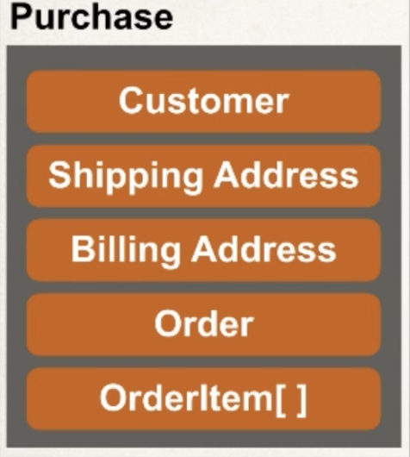
   2. PurchaseResposne: use this class to send back a Java object as JSON
4. Create repository
   1. CustomerRepository
5. Create service
   1. New package: service -> new Interface: CheckoutService
   2. New Java class: CheckoutServiceImpl
6. Create controller
   1. New Package: controller -> new Java class: CheckoutController

24 save the checkout form to database – frontend

1. Create common classes
   1. Customer, Order, OrderItem, Address, Purchase
2. Create CheckoutService
   1. Make REST API call to Spring Boot backend
3. Update CheckoutComponent
   1. Inject CheckourService and Router
   2. Update onSubmit() method to collect form data, call CheckourService

25 Release 3.0 – Security Login/ Logout

Dvelopment Process – Angular

1. Create a free developer account at okta.com
2. Add OpenID Connect client app in Okta
3. Set up app configuration for OpenID Connect
   1. ng generate interface config/MyAppConfig
4. Install Okta SDK dependencies
   1. npm install @okta/okta-signin-widget@6.2.0  
      npm install @okta/okta-angular@5.2.0  
      npm install @okta/okta-auth-js@6.4.0
5. Integrate Okta Sign-In Widget
   1. Augular.json: "node_modules/@okta/okta-signin-widget/dist/css/okta-sign-in.min.css"
6. Develop login status component for login/logout buttons
   1. Ng generate component components/login
   2. ng generate component components/LoginStatus
7. Update App Module configs to connect routes

Okta Safe Code: 83NAYE73QDMHDFAQUG69EL5Y

26 VIP access

1. Generate members-page component
   1. Ng generate component components/MembersPage
2. Update template text in HTML page
3. Add “Member” button to login-status component
4. Define protected route for members-page component

27 Browser Refresh

Origin = protocol + hostname + port  
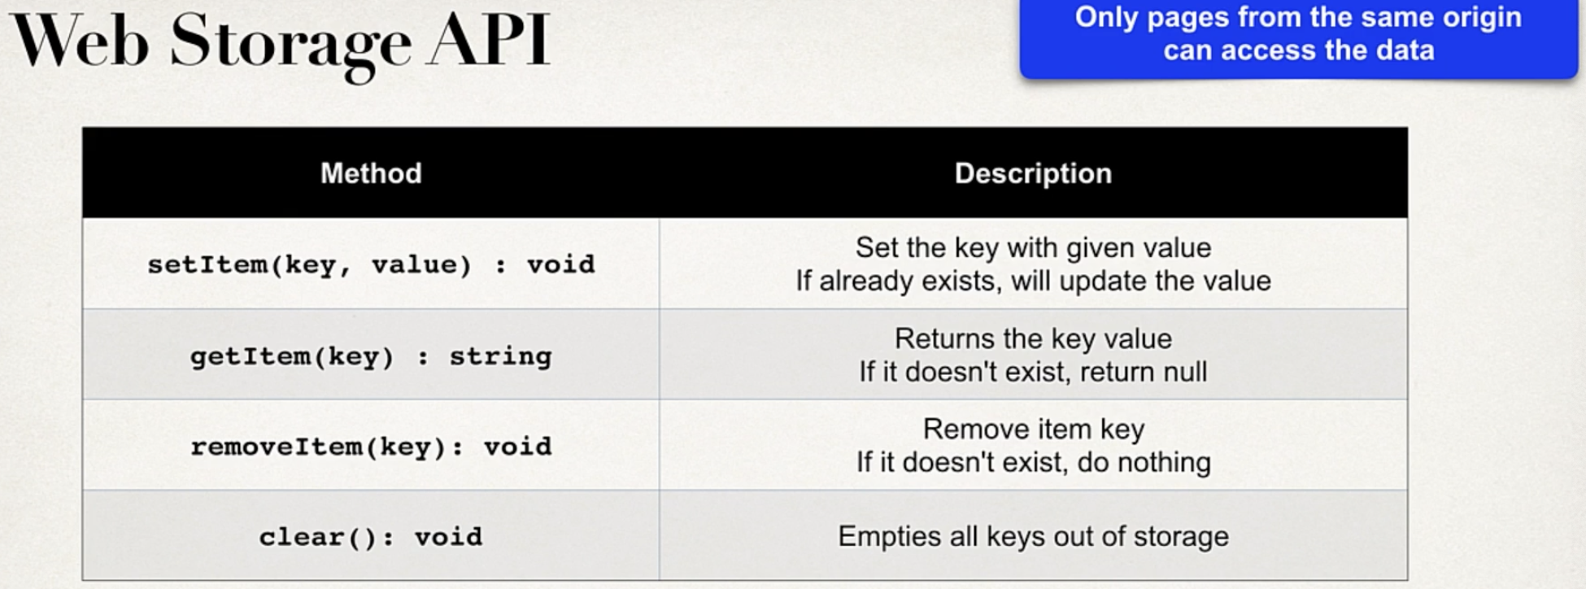

1. Update CartService to read data from session storage
   1. Reading data from storage
2. Add new method in CartService: persistCartItems()
3. Modify computeCartTotals() to call new method: persistCartItems()

28 Refactoring

1. Remove existing data from database tables  
   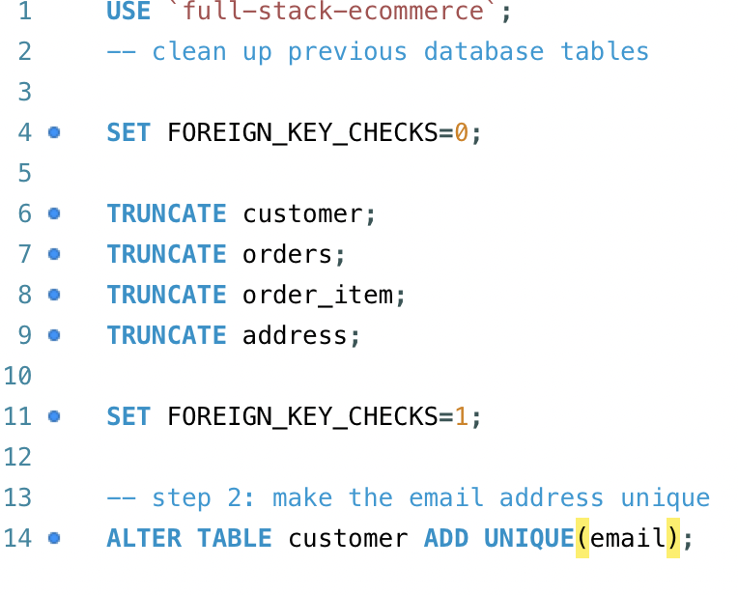
2. Modify database schema to only allow unique email addresses
3. Add new method to CustomerRepositroy
   1. findByEmail(String theEmail);
4. Update CheckoutServiceImpl
   1. Check if customer already exists … if so then use the existing customer

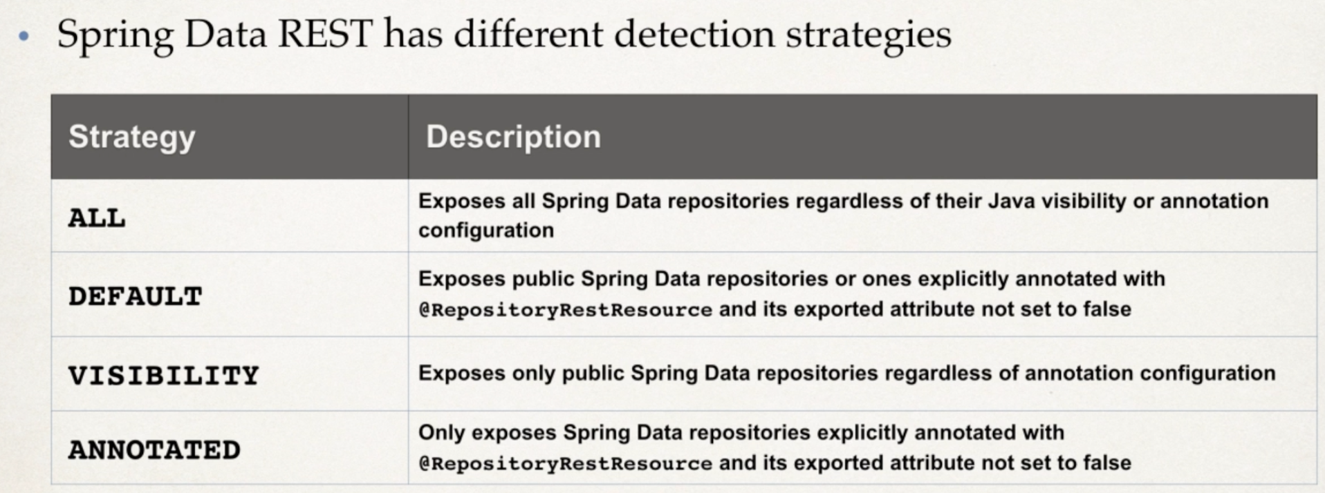

1. Fix deprecated method for SpringData REST
2. Configure CORS mapping for Spring Data REST
3. Configure CORS mapping for @RestController
4. Disable HTTP PATCH method
5. Modify Spring Data REST Detection Strategy

29 view order history

Spring Boot

1. Create OrderRepositroy REST API  
   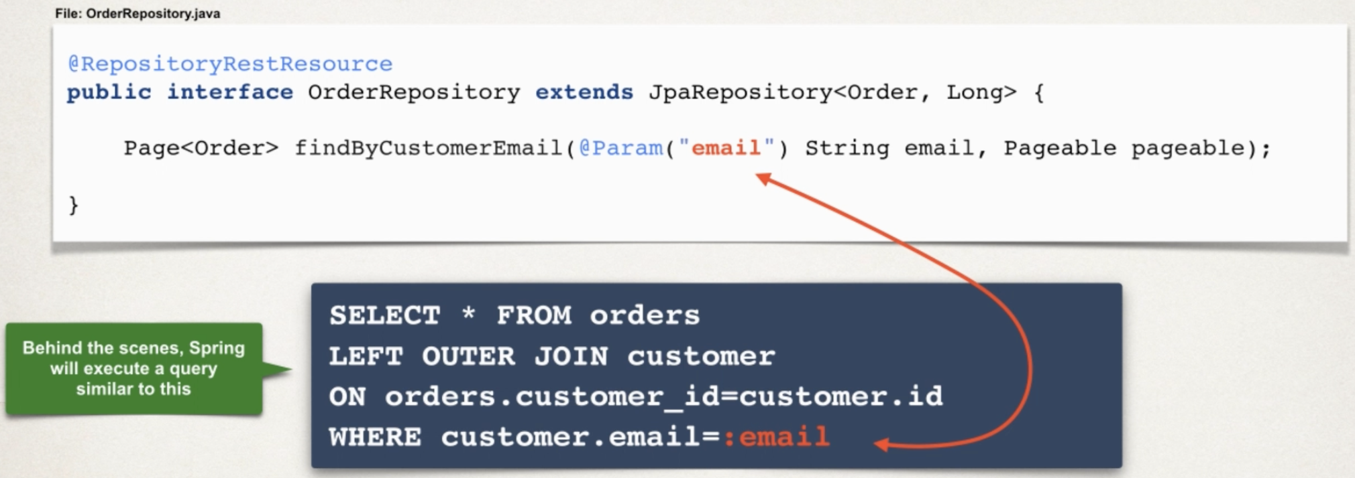
2. Update configs to make OrderRepositroy REST API read only

Angular

1. Keep track of logged in user’s email with web browser storage
   1. Login-status.component.ts: add storage & getUserDetails()
2. Create OrderHistory class
   1. Ng generate class common/OrderHistory
3. Develop OrderHistory service
   1. Ng generate service services/OrderHistory
4. Generate order-history component
5. Update template text in HTML page
6. Add Orders button to login-status component
   1. Login-status.component.html add button for orders
7. Define protected route for order-history component

30 Security order history

1. Add Okta Spring Boot starter to Maven pom.xml
2. In Spring Boot app, set application properties
   1. Okta client-id: 0oaiqwp9t0KQ79sLA5d7
   2. Okta issuer: dev-38053166.okta.com
3. Protect endpoints in Spring Security configuration class

31 secure frontend

1. Create an interceptor
   1. Auth-interceptor.service.ts
2. Update app.module.ts to reference interceptor

32 HTTPS – frontend

HTTPS, SSL, TLS

[www.luv2code.com/https-additional-resources](http://www.luv2code.com/https-additional-resources)

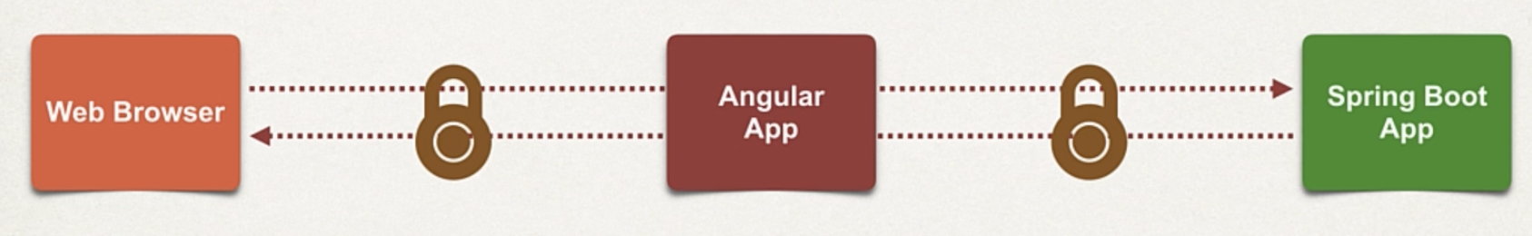

1. Generate key and self-signed certificate
   1. [www.luv2code.com/openssl-setup](http://www.luv2code.com/openssl-setup)  
      -> ssl-localhost folder: localhost.crt & localhost.key
   2. To view the certificate: Openssl x509 -noout -text -in ssl-localhost/localhost.crt
2. Run Angular App with the key and self-signed certificate
   1. Package.json -> scripts -> start
3. Update Spring Boot App with new URL
   1. Application.properties: update allowed.origins
4. Update Redirect URI in Angular App
   1. Src -> apii -> config -> myAppConfig
5. Update Redirect URIs in Okta Dashboard
6. Update API Trusted Origins in Okta Dashboard

33 HTTPS security backend

1. Generate key and self-signed certificate  
   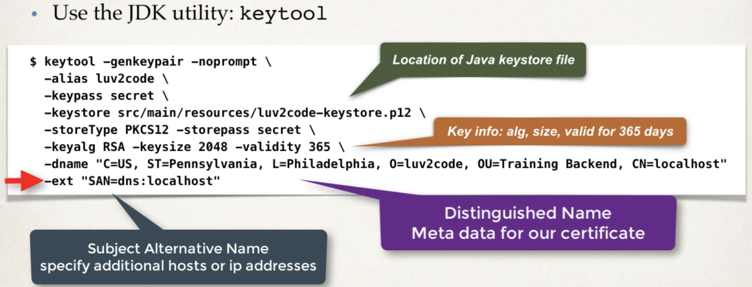
2. Update application.properties with security configs
   1. [www.luv2code/keytool-steps](http://www.luv2code/keytool-steps)

34 Angular Environment Configuration

1. Define configs in environment file
   1. Update service urls
2. Use environment in your app
3. Run with environment configuration
4. Create environment file: environment.qa.ts
5. Define configuration in angular.json for “build” section  
   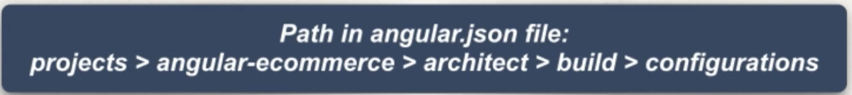
6. Define configuration in angular.json for “serve” section
7. Run with environment configuration

Send email after successful payment

1. Angular:
   1. Add email field to payment-info.ts
   2. In onSubmit(), assign email field to customer’s email address
2. Spring Boot
   1. Add email field to PaymentInfo.java
   2. In createPaymentIntent(), assign email address

34 Stripe

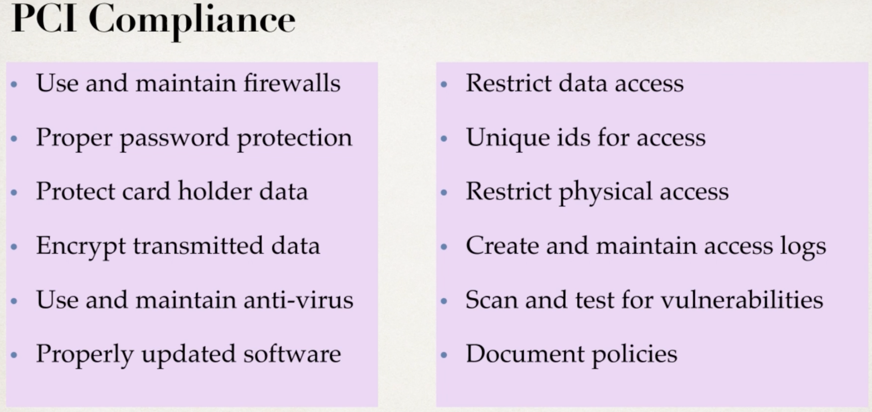

Development Process – Backend

1. Create Stripe Developer Account
2. Add Stripe Maven Dependency
3. Configure Stripe API Key
4. Create custom PaymentInfo DTO
5. Update CHeckoutService to create a PaymentIntent
6. Update CheckoutController to expose / payment-intent endpoint

Frontend

1. Install Stripe API
2. Create a TypeScript declaration file: typings.d.ts
3. Add Stripe Publishable key
4. Create custom PaymentInfo DTO: ng generate class common/PaymentInfo
5. Update CheckoutService to create a PaymentIntent
6. Load Stripe JavaScript library in index.html
7. Add Stripe Elements to Checkout form

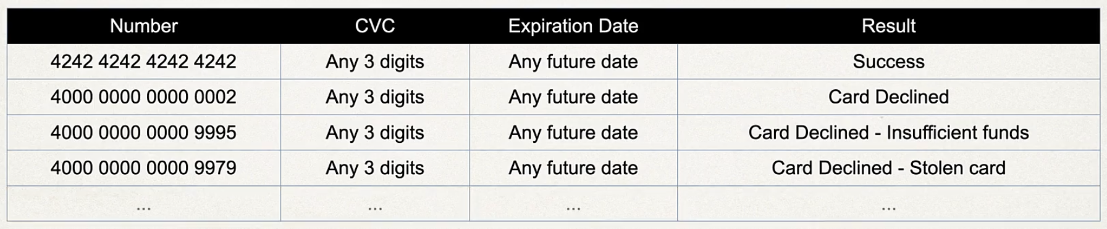

Accomplishements

* Developed an E-Commerce Shopping Cart app – Full Stack
* Created frontend and backend using Angular and Spring Boot
* Secured the application with JWT, OAuth2 and OpenID Connect
* Encrypted data communications with TLS / SSL (https)
* Processed credit card payment with Stripe API